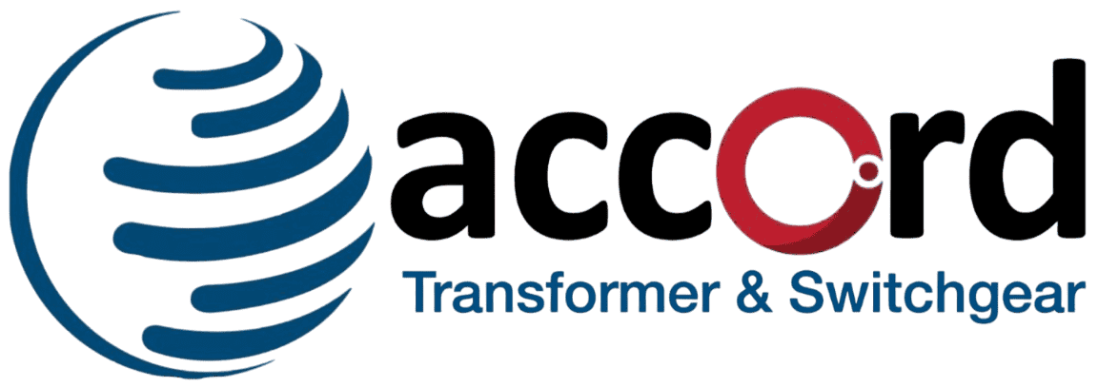
Accord Transformer & Switchgear Ltd
Accord Transformer & Switchgear Ltd Achieves Major Technological Milestone with Successful Dynamic Short Circuit Test

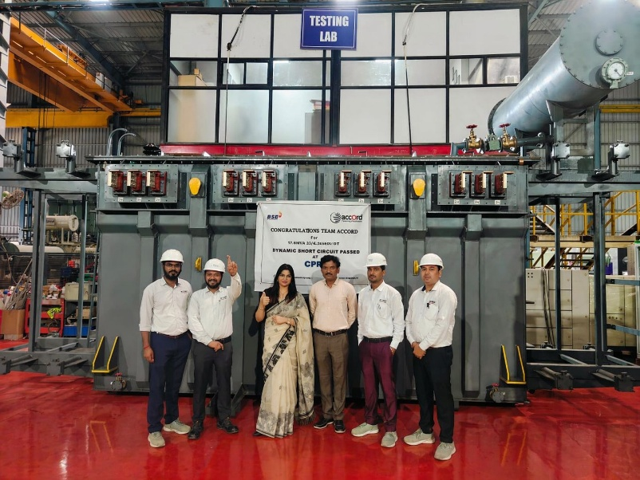

Mumbai, India, April 29, 2026: Accord Transformer & Switchgear Ltd has successfully completed the Dynamic Short Circuit Test for its 17.6 MVA, 33kV / 4x660V Inverter Duty Transformer, marking a significant milestone in the company’s engineering and manufacturing journey.

The rigorous test was conducted at the prestigious Central Power Research Institute (CPRI), validating the transformer’s ability to withstand extreme electrical stress conditions. This achievement underscores the company’s commitment to delivering high-performance, reliable, and future-ready power solutions for demanding industrial and renewable energy applications.

Key Highlights of the Achievement
- Demonstrates robust design and strong engineering capabilities
- Successfully meets stringent national testing standards
- Enhances reliability for critical industrial and renewable energy deployments
- Strengthens positioning in the power infrastructure and inverter-duty transformer segment

The successful testing reinforces the product’s durability and operational reliability, making it well-suited for high-stress environments and mission-critical applications.

Strategic Significance
This milestone reflects Accord Transformer & Switchgear Ltd’s continuous focus on innovation, quality assurance, and adherence to industry-leading standards. With increasing demand for reliable and efficient power equipment, especially in renewable energy and industrial applications, the company remains well-positioned to capitalize on emerging opportunities.

The accomplishment also highlights the dedication and expertise of the company’s engineering and technical teams, who have consistently worked towards delivering advanced and dependable solutions.

About Accord Transformer & Switchgear Ltd

Accord Transformer & Switchgear Ltd is engaged in the manufacturing of transformers and power equipment, catering to a wide range of industrial and infrastructure applications. The company focuses on delivering high-quality, efficient, and technologically advanced solutions, supported by strong engineering capabilities and a commitment to excellence.

Disclaimer
Certain statements in this document that are not historical facts are forward looking statements. Such forward-looking statements are subject to certain risks and uncertainties, including but not limited like government actions, local, political or economic developments, technological risks, and many other factors that could cause actual results to differ materially from those expressed or implied in the relevant forward-looking statements. The Company will not be in any way responsible for any action taken based on such statements and undertakes no obligation to publicly update these forward-looking statements to reflect subsequent events or circumstances.

For Further Information Please Contact Corporate Communication Advisor:

